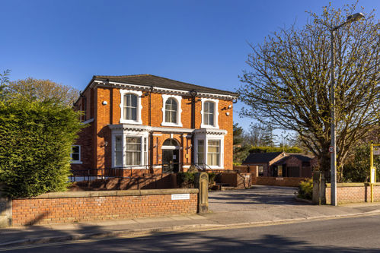

The Grange Surgery

41 York Road, Birkdale, Southport, Merseyside, PR8 2AD

01704 560506 gp.n84024@nhs.net

Date:
Specialists name:
Hospital name and Address:

Dear Colleague,
Your Full Name:
Your Date of Birth:
Your NHS Number:
Your Address:
Your preferred telephone number:

Our mutual patient is receiving care from you for:
Write your original problem here
They await a follow-up appointment and / or treatment, but report the following change in their condition since your last contact with them:
Explain briefly what has changed since your last contact with the specialist

We request that you take the following action
- Review the patient’s hospital notes alongside this letter to determine whether their care might be expedited
- Contact the patient directly to inform them of the outcome of that decision, and their likely wait for further care
- File this letter and document your decision in the patients’ medical record.

Yours faithfully,
Dr’s Forshaw, Nayak and Eyres.

