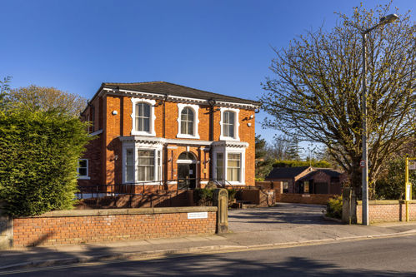

The Grange Surgery

41 York Road, Birkdale, Southport, Merseyside, PR8 2AD

01704 560506 gp.n84024@nhs.net

Date:
Outpatient Address or Hospital Address:

Dear Sir/Madam,
Your Full Name:
Your Date of Birth:
Your NHS Number:
Your Address:
Your preferred telephone number:

This patient was referred to you for assessment of:
Write your original problem here
We would be grateful if you could consider expediting this appointment based on the below:

Explain briefly what has changed since The Grange Surgery referred you to the specialist

We request that you take the following action
- Pass the original referral letter and this letter to a clinician to determine whether their assessment might be expedited
- Contact the patient directly to inform them of the outcome of that decision, and their likely wait for an appointment
- File this letter and document your decision in the patients’ medical record.

Yours faithfully,
Dr’s Forshaw, Nayak and Eyres.

